TA6478 Implement Logging in HAPI FHIR

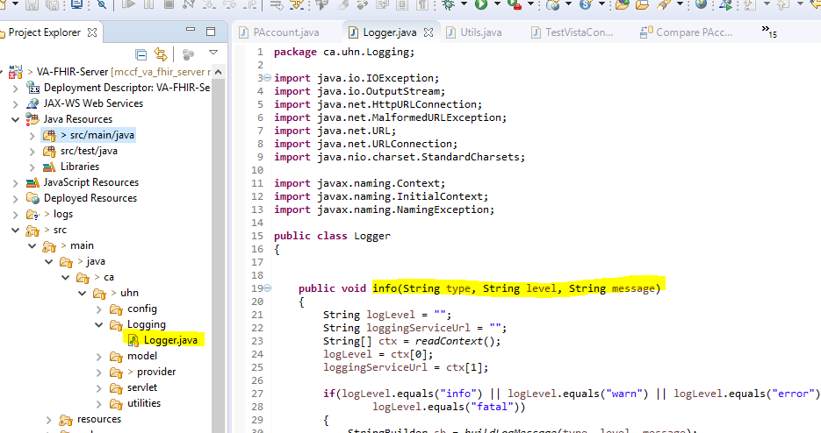

A new class ‘Logger.java’ has been developed. It has different methods for different log levels.

The logger can be called as follows:

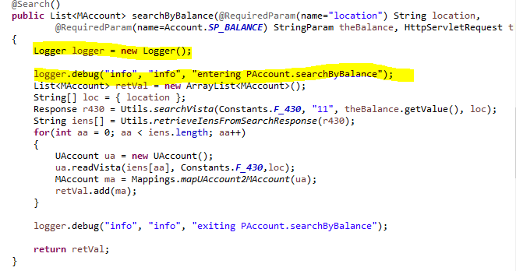

The Logger calls the logging service which stores the logging message.

To be able to log, the file VA-FHIR-Server in /conf needs to be extended:

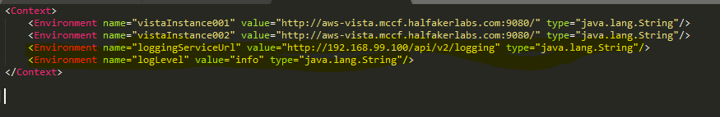

Calling the logging service

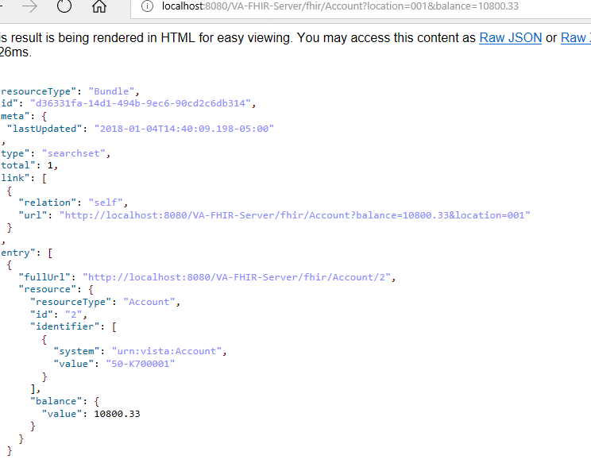

Creates following log entry

